Inner Personality
The Primary Emotions for Human (Ekman / Plutchik models):-
1. Joy
2. Trust
3. Fear
4. Surprise/Shock
5. Sadness
6. Disgust
7. Anger
8. Anticipation
9. Joy + Trust = love
10. Anger + Disgust = Contempt
11. Fear + Surprise = Awe
12. Sadness + Disgust = Remorse
13. Surprise + Anticipation = Optimism
14. Anger + Anticipation = Aggressiveness
15. Fear + Sadness = Despair
16. Joy + Surprise = Delight
Emotions are temporary internal states triggered by events. They Come -> Peak -> Fade.

The 5-Layer Human Model:-
1. Emotion (Momentary State):- A short-term internal feeling triggered by events
Examples:- Anger, Fear, Joy, Disgust, Sadness

2. Trait (Emotinal Tendency):- An emotion represents so often it becomes a default response
Examples:-
Easily Irritated -> Anger prone
Constantly alert -> Anxious
Hard to excite -> Emotionally flat
Optimistic -> Joy Learning
Suspicious -> Fear/Trust imbalance

3. Defence Mechanism (Emotinal Protection):- Automatic psychological strategy to avoid pain
Examples:- Ego -> Dominates to avoid shame
Humor -> Jokes to avoid vulnerability
Detachment -> Shuts down emotions
Control -> Micromanages to avoid chaos
Aggression -> Attacks before being hurt
- Activated when traits are threatened.
- Defence Mechanisms (Inner Mechanisms Not survival) are triggered only when people cross their boundaries. Pushes from their comfort zone, insult their Identity, etc.
4. Habit / Behaviour (Visible pattern):- Repeated external action caused by
Trait + Defence
Examples:- Procrastination, Avoiding Eye contact, Overworking, Interrupting others,
Picking fights, Staying silent
- This is what audience sees

5. Personality (The Full Pattern):- The consistent combination of the above four layers over time
Examples:- Rebellious but wounded
Charming yet emotionally avoidant
Quiet, Intense, and Controlling
Loud, Defensive, Impulsive
The 5-Layer Model Flow:-
EVENT
|
Emotion (What they feel)
|
Trait (What they feel often)
|
Defense (How they Protect)
|
Habit (What they Do)
|
Personality (Who they appear to be)

Behaviours:-
Each Person would behave differently with different people with relations with different intensity of emotions.
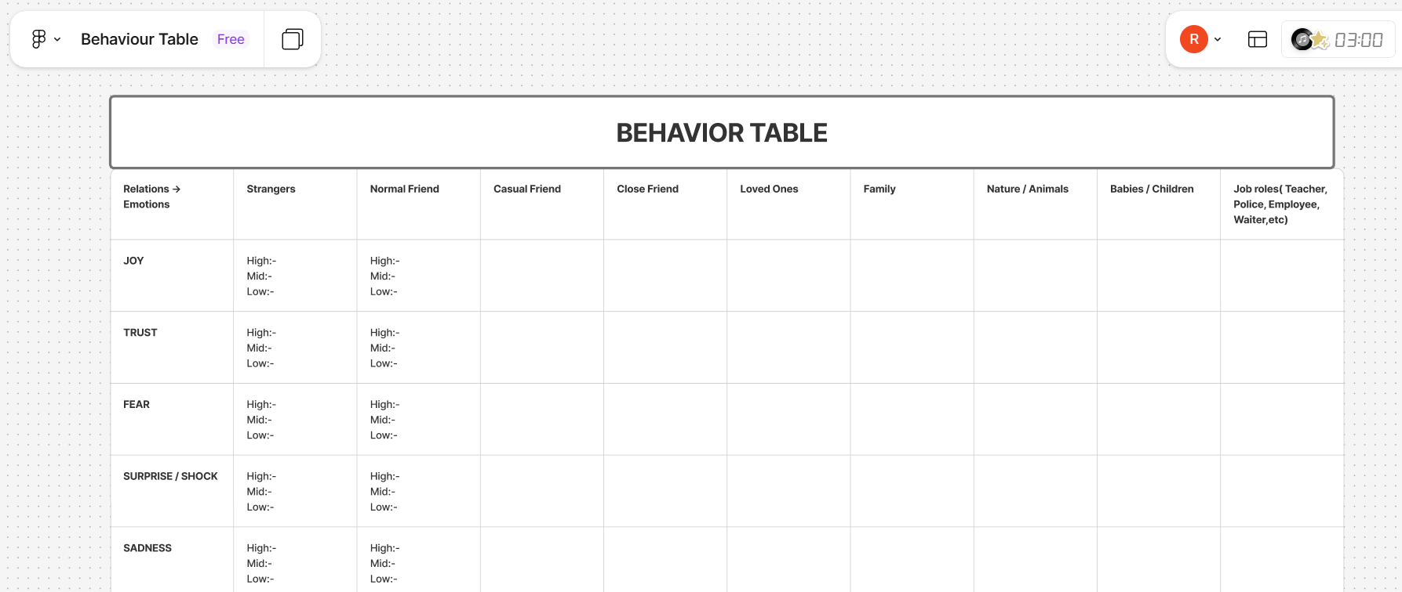

Projection Of Emotions
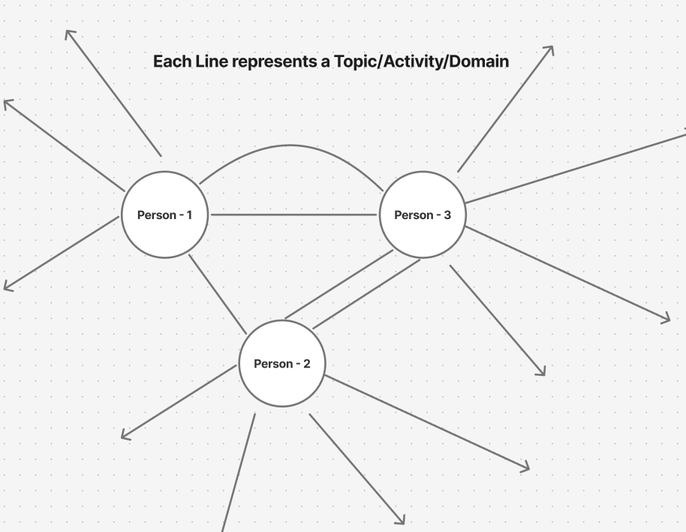

- The person isn’t sharing that topic to the person they he may project that emotion on them instead of sharing.
- Sometimes people who are trusted / Shared may also be affected through the projected emotions but later may realise and explain them.
- Some people may share cautiously to the person they haven’t had enough trust – Cautious sharing.

Note:-
Anger Projection:-
- The person would be waiting for the other person to do something so that they can project anger on them.
- They wantedly search for a minute thing to burst/project on them. If the anger dissolves after bursting/projecting they may realise they unnecessarily said projected.
- But they may apologize to them or find some other valid reason to prove he is valid even though subconsciously they know they are invalid(Unexpressed emotions).

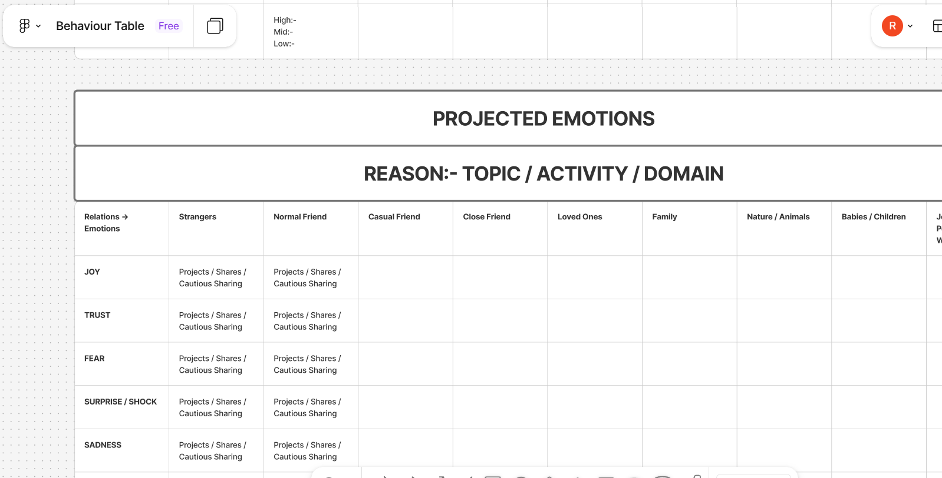

Boundaries
People develop boundaries – The personalities formed due to wounds/Inspiration wont easily dissolve with emotion except when the person is ecstatic – High Joy.

Inner Thoughts
Below is an example of the character Dylan from the movie Friends with Benefits Inner Thought process.
@Layer 5: - She just came to meet me for the bonus check that’s it .
@Layer 4: - Why she is avoiding me suddenly??
@Layer 3: - We just agreed as friends and Now things start to feel out of hands.
Layer 2: - Wants to spend time with her. Hangout together.
Layer 1: - We are just Friends who have sex. No Emotions, No Feelings – Just Friends.
Wound: - Afraid to what happened to his father – His mother left them. So he is afraid to accept a woman into his life and getting into a relationship. (Fear of Losing)
Core: - Fell for Jamie in their journey of Just Sex No Emotions

Note: - layers marked with ‘@’ will happen in the Act-2 and Act-2 is the drama where their core wounds and traits will be in conflict situation. In Act-1 they just enjoy assuming there were no emotions. But when his sister starts to name their closeness, his ego mechanism starts as he is also in the same dilemma with trait and wound but neglected it instead of addressing it.
He lied to himself saying we are just friends even though in his core he built feelings for her. He is believing his Layer 1 (Fake truth) instead of actual Core truth. But its been addressed by his sister - his fake truth got exposed and doesn’t had answer to his sister question. So he got pissed off / irritated – Ego defence mechanism came in through wound.

